Photon PUN2 Enter Exit with Realistic Car Controller V3.4

Importing Packages
First, download and import Photon2. Pass your AppID to Photon setup (expalined below), and then import “RCC_PhotonNecessaryScripts” in Scripts/Photon folder. Now you can test the Photon demo scene.

There should be a new scene named “RCC City Enter Exit FPS (Photon PUN2)” in Demo Scenes folder after importing the integration package. Same scene with regular Photon PUN2 city scene. Only difference is, this scene has “BCG_PhotonManagerEnterExit” instead of “RCC_PhotonManager” with script.

Known Bug
There is an option named “Enable Photon Enter Exit” button in Enter Exit Settings. This button needs to be refreshed. Disable it and re-enable it. This process will add “BCG_ENTEREXITPHOTON” scripting symbol into your Build Settings. Disabling it again will remove this scripting symbol from your Build Settings.
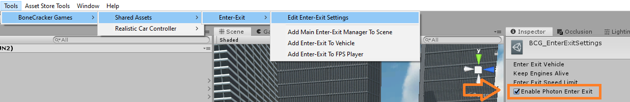

I would recommend you to read Realistic Car Controller V3.4 Photon PUN2 Integration documentation before reading this.

Once we connect to lobby with “BCG_PhotonManagerEnterExit”, automatic room join/create will be initiated. After creating / joining random room, “Spawn Player” button will be visible. This button is only visible when we are in active room. This button will instantiate BCG_FPSPlayer with “PhotonView” component attached to it.

Each vehicle on the scene has “RCC_PhotonNetwork”, “BCG_PhotonNetwork” scripts. When FPS Player enters the vehicle, “BCG_PhotonManagerEnterExit” will request ownership of the vehicle to the FPS Player. When FPS Player exits the vehicle, “BCG_PhotonManagerEnterExit” will transfer ownership to 0. That means, owner of the vehicle is null.

